New version 3.6.6
This new version supports code generation from Astah* models with regions. A region is an orthogonal part of a state. Regions allow to express parallelism within a state. A state can have two or more regions. Region contains states and transitions. To add a region in astah* right click to a state and select Add region from the context menu.
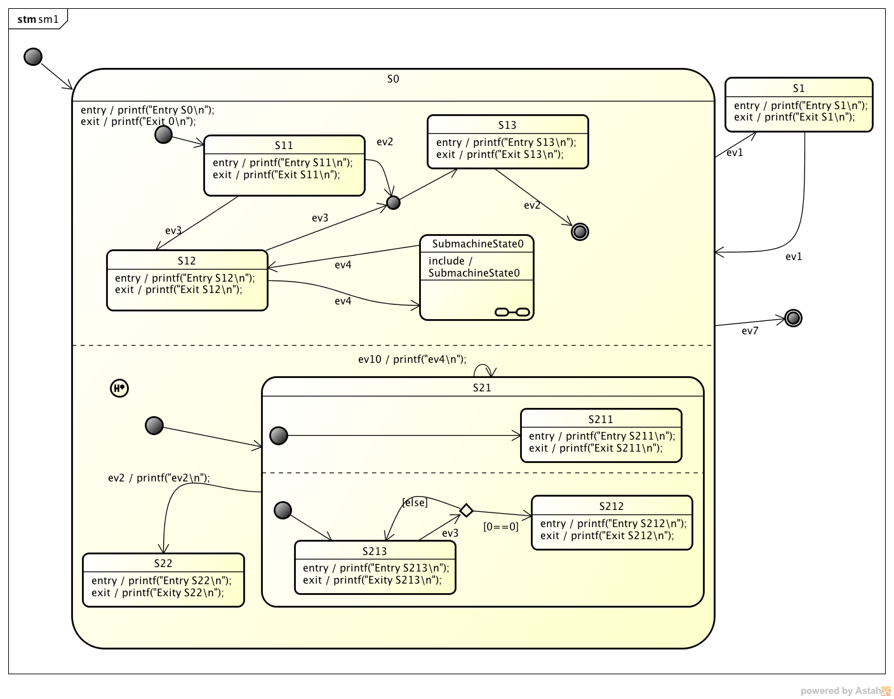
An example state diagram with regions is shown below:
For more information how the code generator generates code from regions download the latest version and check-out the manual esp. sections 2.2 and A.5.
{(rater>id=01092014|name=How do you like this article?|type=rate)} ~~DISCUSSION|Leave your comments~~

